

Microfinance Ireland

Report on
The Microenterprise Loan Fund Scheme
As of the 31st of December 2024

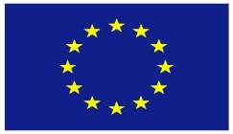
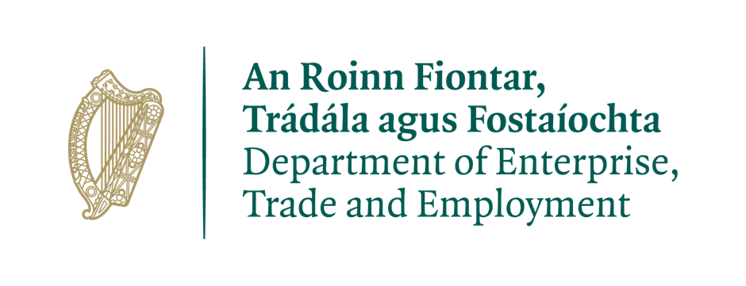

This financing benefits from a guarantee issued under the ‘European Progress Microfinance Facility’, the ‘Employment and Social Innovation Guarantee Facility’ and the Pan European Guarantee Fund in Response to COVID-19 established by the European Union.

Overview of the Microenterprise Loan Fund Scheme
The Microenterprise Loan Fund, administered by Microfinance Ireland was established as part of the Government’s Action Plan for Jobs and forms part of a suite of financial programmes provided through the Department of Enterprise, Trade and Employment to assist businesses of different sizes and at different stages of development across all industry sectors.
The purpose of the Fund is to provide loans of €2,000 up to €50,000 to Micro-enterprises, both startups and existing businesses with viable businesses, who cannot obtain funding through traditional sources. (Microenterprises are defined as businesses with less than 10 employees and /or Turnover <€2m)
Fund Performance Summary: 1st October 2012 to 31st December2024
As at end 31st December2024, Microfinance Ireland has been in business for 13 years. In this time, it has delivered the following key results:
- 11,927 Applications received.
- €92.6M Value of loans approved
- 10,957 Net jobs supported in 5,594 micro-enterprises.
- 47% Approval rate
- €82.1M Value of loans drawn
- 4,994 Loans drawn.
- Average Loan size of €16.9K
- 82% approvals granted to businesses employing 3 people or fewer.
- 43% of approvals granted to start-ups (in business for less than 18 months)
- Wide geographic coverage: 22% of loans granted to Dublin,78% to the rest of Ireland

Successful applicants by sector YTD 2024

WHOLESALE AND RETAIL TRADE; REPAIR OF MOTOR VEHICLES AND MOTORCYCLES (19%) | ACCOMMODATION AND FOOD ACTIVITIES (10%)
CONSTRUCTION (11%) | OTHER SERVICES (10%)
PROFESSIONAL, SCIENTIFIC & TECH ACTIVITIES (9%) | MANUFACTURING (7%)
HUMAN HEALTH AND SOCIAL ACTIVITIES (7%) | TRANSPORT AND STORAGE (6%)
ARTS, ENTERTAINMENT AND RECREATION (6%) | EDUCATION (5%)
ADMINISTRATION & SUPPORT SERVICES. ACTIVITIES (5%) | INFORMATION AND COMMUNICATION (4%)
OTHER (1%) | AGRICULTURE, FORESTRY & FISHING (0%)
Assessing applications efficiently:
- 11,799 Applications processed to full assessment.
- 111 Applications in progress at reporting date
- Endeavour to process complete applications within 10 days.

Promotion and performance of the Fund during 1st January 2024 to 31st December2024

Key performance indicators YTD 2024
- 1,062 Applications received.
- €9.1M Value of loans approved
- 911 Jobs supported in 517 micro-enterprises.
- 52% Approval rate
- €7.5M Value of loans drawn
- 450 Loans drawn.
- Average Loan size of €16.6K
- 87% approvals granted to businesses employing 3 people or fewer.
- 46% of approvals granted to start-ups (in business for less than 18 months)
- Wide geographic coverage: 22% of loans granted to Dublin,78% to the rest of Ireland.

Key performance indicators Qtr. 4 2024

- 364 Applications received.
- €3.4M Value of loans approved
- 308 Jobs supported in 153 micro-enterprises.
- 47% Approval rate
- €2.5M Value of loans drawn
- 133 Loans drawn.
- Average Loan size of €19.2K
- 90% approvals granted to businesses employing 3 people or fewer.
- 44% of approvals granted to start-ups (in business for less than 18 months)
- Wide geographic coverage: 22% of loans granted to Dublin, 78% to the rest of Ireland.

During the 4rd quarter of 2024, MFI continued to engage in a range of Marketing and PR initiatives.

Radio Advertising:
We ran an advertising campaign over an extended period in the quarter which was targeted at both national and local listeners.
Digital Advertising /social media:
We continue with ongoing promotion through our social media channels, Facebook, Instagram, Twitter, and LinkedIn to maintain strong brand awareness with digital advertising campaigns primarily focussed on Google and Facebook.

Events/Webinars/Sponsorships:
We continue our representation at in person events and webinars. During the last quarter we participated in the National Women’s Enterprise Day events. We were also represented at the Small Firms Association Business to Business event which gave us the opportunity to raise awareness of our offering and particularly the recent increase in the maximum loan amount to €50k.

In this quarter we celebrated European Microfinance Day with a special webinar in conjunction with the Fingal LEO.

We have held webinars in collaboration with a number of the Local Enterprise Offices and these webinars have been well attended and seem to be well received by the LEO clients.

We continue to have monthly webinars for anyone interested in Microfinance Ireland and have included the calendar of webinars on our website. These webinars continue to be well attended with good engagement from participants.

We were sponsors of a number of startup and established businesses events and awards throughout 2024. These events are important for building brand awareness.

Performance:
Applications in Q4 were very strong reflecting the demand for loans in excess of €25k. We ended the year with 1,062 applications which was close to 90% of our original target.

Our approval rate for the quarter at 47% is running around the long-term average. On average we achieved approval rates of 52% for the year which is a reflection of our goal to support as many businesses as possible while maintaining our credit standards.

Applications from Start Ups accounted for c. 46% of all approvals.

In the year to date, applications from Female business owners accounted for c. 32% of all applications.

Loans to businesses located outside of Dublin accounted for c. 76% of all loans which is in line with historic numbers.

Microenterprise Loan Fund Scheme Analysis

January 2021 – 31st December2024

Quarterly Growth Trend

Application and approval activity levels by Quarter are displayed in the graph below:
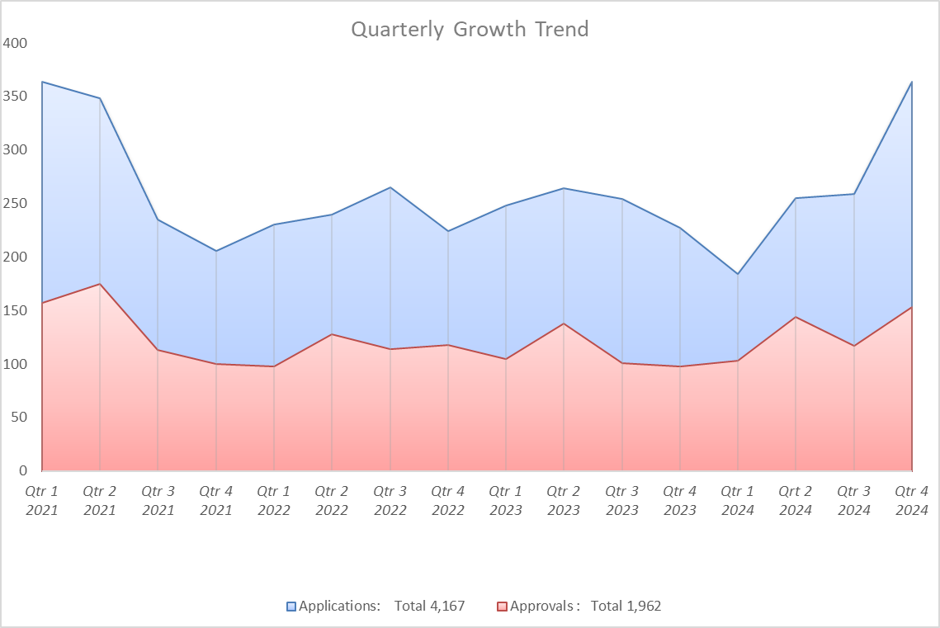

Applications processed (1st January 2024 - 31st December2024)

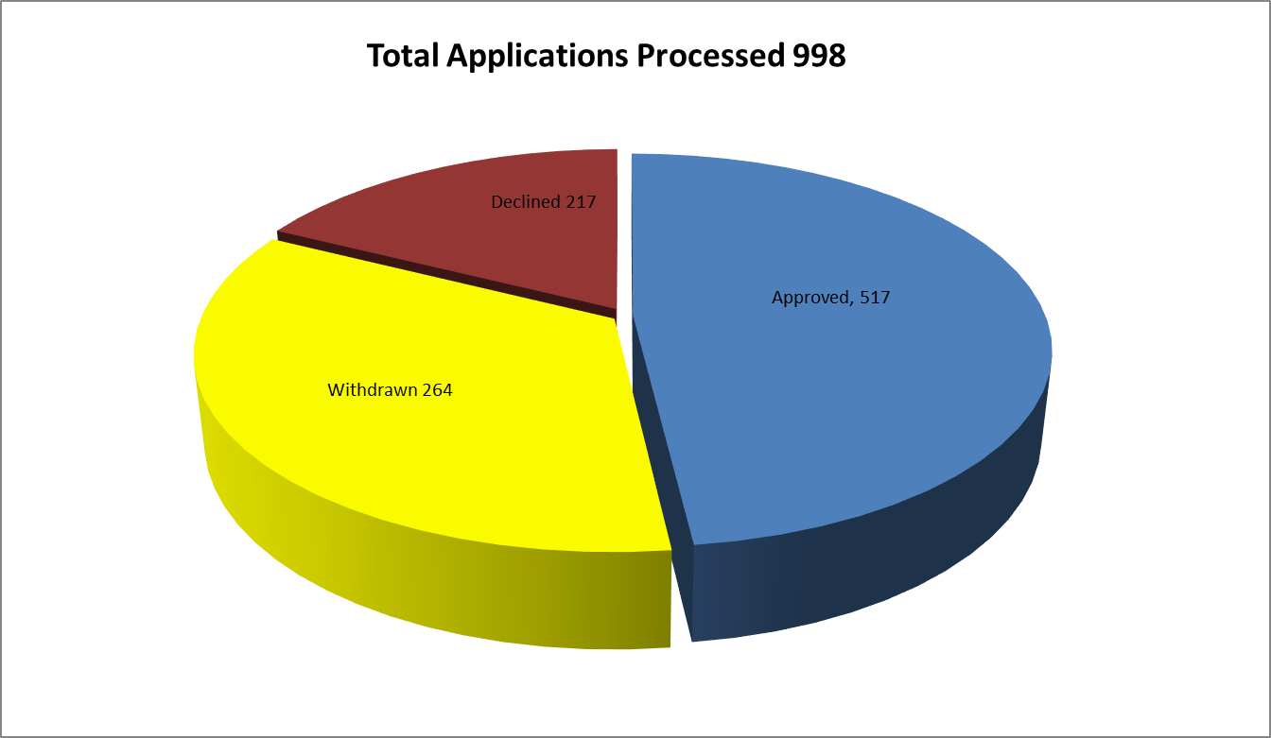

Number of Loans by Sector

Values of Loans by Sector

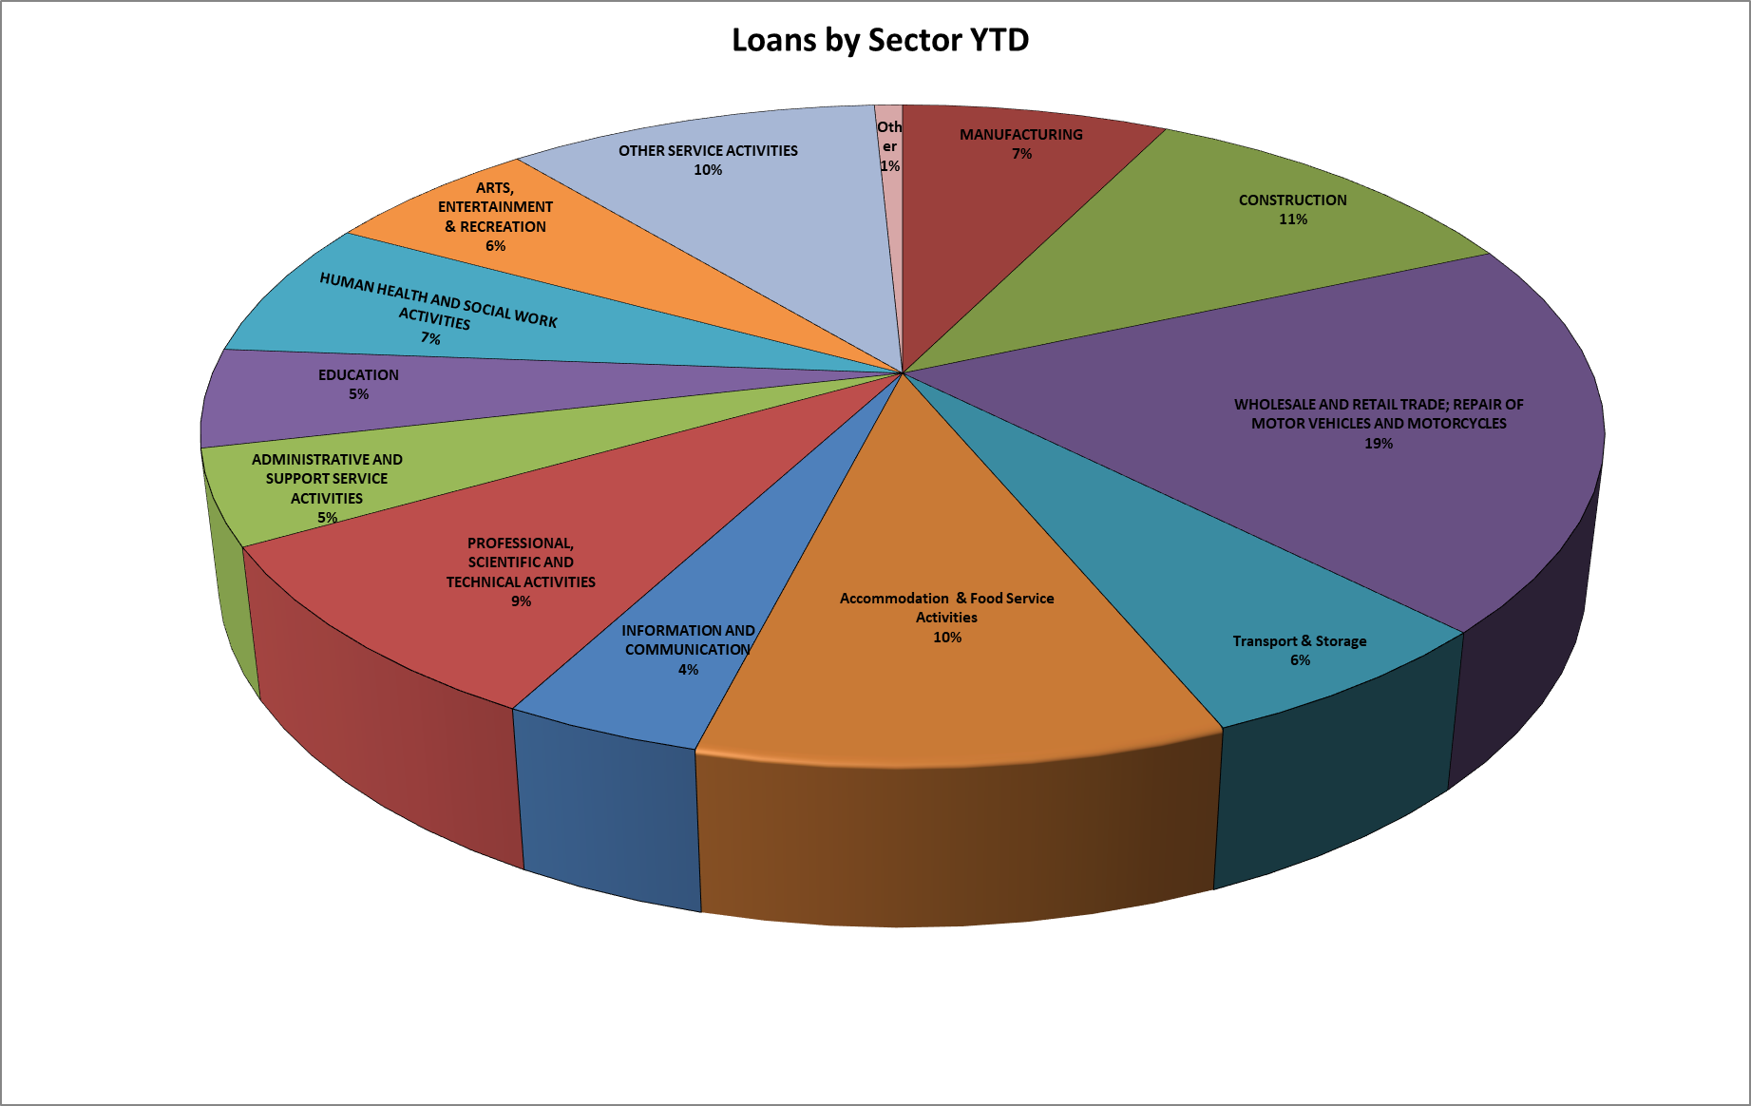

Approvals by Size of Borrower

From 1st January 2021 to 31st December2024
Loans were approved to micro-enterprises with the following number of jobs at time of approvals:

Approvals by Loan Size
From 1st January 2021 to 31st December2024, loans were granted in the following size range.

Purpose for which Microfinance Loans were granted.

Geographical Analysis of Approval – from 1st January 2024 to 31st December2024

Approval by Business Sector January 2024 to 31st December2024

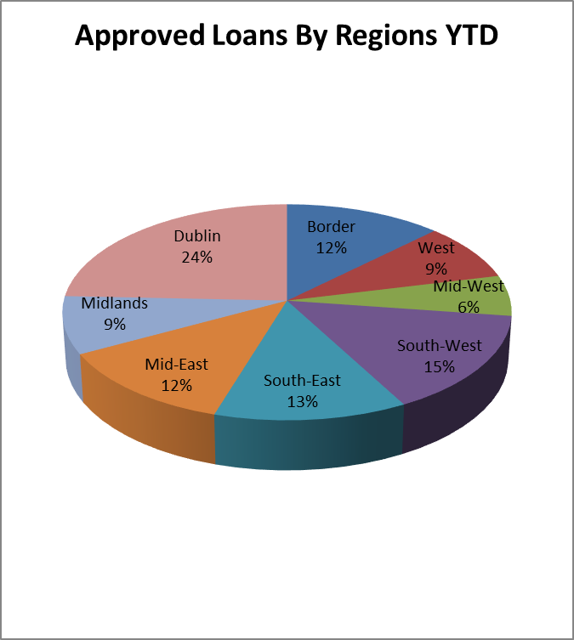

Demographical Analysis

Source of Loan Referrals

Appeals Process

The purpose of the Microfinance Ireland appeals process is to support an applicant who wishes to have a review of an MFI decision to declining a loan application.
MFI will appoint an Appeal Assessor to carry out an independent review of the original loan decision. The assessor who was involved in the original decision will not be involved in the appeals process. The outcome of this review is communicated in writing to the applicant within 15 business days of receipt of the written appeal. The credit decision of the Appeal Assessor is independent of MFI management and is final. There have been 27 appeals in 2024 and 11 of these cases have been approved on appeal. These figures are included in the YTD approval figures.

Complaints
1 complaint were received by the business in Quarter 4 2024.

Business Failures

During 2024, 42 businesses of our borrowers have failed. While any business failure is regrettable, it was anticipated from the outset that a not insignificant proportion of projects supported by the Microfinance Ireland might fail. It is a feature of microfinance (given the higher risk profile) that even with strong business supports, failures will occur.

On an ongoing basis, Microfinance Ireland, in conjunction with other agencies, works with every customer at risk to minimise business failure.

