

Microfinance Ireland

Report on
The Microenterprise Loan Fund Scheme
As of the 31st of March 2025


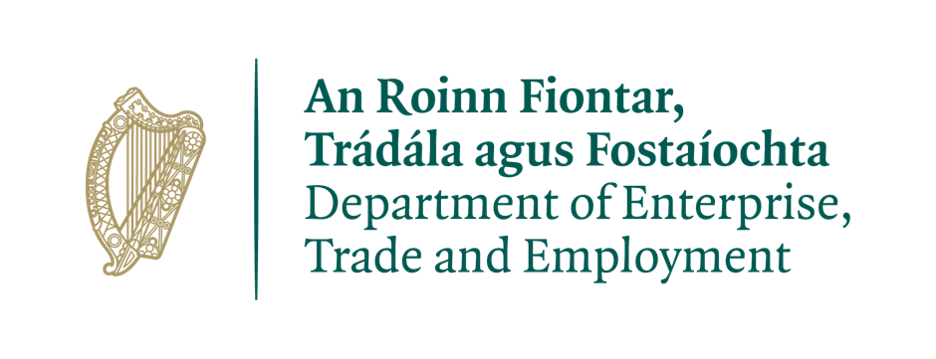

This financing benefits from a guarantee issued under the ‘European Progress Microfinance Facility’, the ‘Employment and Social Innovation Guarantee Facility’ and the Pan European Guarantee Fund in Response to COVID-19 established by the European Union.

Overview of the Microenterprise Loan Fund Scheme
The Microenterprise Loan Fund, administered by Microfinance Ireland was established as part of the Government’s Action Plan for Jobs and forms part of a suite of financial programs provided through the Department of Enterprise, Trade and Employment to assist businesses of different sizes and at different stages of development across all industry sectors.
The purpose of the Fund is to provide loans of €2,000 up to €50,000 to Micro-enterprises, both startups and existing businesses with viable businesses, who cannot obtain funding through traditional sources. (Microenterprises are defined as businesses with less than 10 employees and /or Turnover <€2m)
Fund Performance Summary: 1st October 2012 to 31st March 2025
As at end 31st March 2025, Microfinance Ireland has been in business for 13 years. In this time, it has delivered the following key results:
- 12,289 Applications received.
- €95.8M Value of loans approved
- 11,334 Net jobs supported in 5,727 micro-enterprises.
- 47% Approval rate
- €85M Value of loans drawn
- 5,115 Loans drawn.
- Average Loan size of €17K
- 84% approvals granted to businesses employing 3 people or fewer.
- 43% of approvals granted to start-ups (in business for less than 18 months)
- Wide geographic coverage: 22% of loans granted to Dublin,78% to the rest of Ireland

Successful applicants by sector YTD 2025

WHOLESALE AND RETAIL TRADE; REPAIR OF MOTOR VEHICLES AND MOTORCYCLES (23%) | ACCOMMODATION AND FOOD ACTIVITIES (12%)
OTHER SERVICES (10%) | PROFESSIONAL, SCIENTIFIC & TECH ACTIVITIES (8%)
CONSTRUCTION (7%) | MANUFACTURING (7%)
HUMAN HEALTH AND SOCIAL ACTIVITIES (7%) | TRANSPORT AND STORAGE (6%)
ARTS, ENTERTAINMENT AND RECREATION (6%) | EDUCATION (5%)
ADMINISTRATION & SUPPORT SERVICES. ACTIVITIES (5%) | INFORMATION AND COMMUNICATION (3%)
OTHER (1%) | AGRICULTURE, FORESTRY & FISHING (0%)
Assessing applications efficiently:
- 12,187 Applications processed to full assessment.
- 102 Applications in progress at reporting date
- Endeavour to process complete applications within 10 days.

Promotion and performance of the Fund during 1st January 2025 to 31st March 2025

Key performance indicators YTD 2025
- 362 Applications received.
- €3.2M Value of loans approved
- 221 Jobs supported in 133 micro-enterprises.
- 36% Approval rate
- €2.9M Value of loans drawn
- 121 Loans drawn.
- Average Loan size of €23.8K
- 86% approvals granted to businesses employing 3 people or fewer.
- 50% of approvals granted to start-ups (in business for less than 18 months)
- Wide geographic coverage: 19% of loans granted to Dublin, 81% to the rest of Ireland.

During the 1st quarter of 2025, MFI continued to engage in a range of Marketing and PR initiatives.

Radio Advertising:
We did not run a radio campaign in Q1 but expect to have a number of campaigns over the remainder of 2025.
Digital Advertising /social media:
We continue with ongoing promotion through our social media channels, Facebook, Instagram, Twitter, and LinkedIn to maintain strong brand awareness with digital advertising campaigns primarily focussed on Google and Facebook. We recently soft launched some content on our Tik Tok channel and will monitor the impact of this channel.

Events/Webinars/Sponsorships:
We continue our representation at in person events and webinars. In Q1 we hosted our own International Women’s Day webinar with one of our clients as a guest speaker. This event was very well attended and was targeted at raising our profile among female entrepreneurs. We were also represented at the Small Firms Association National Small Business Awards where we sponsored the Emerging New Business category.
We have held webinars in collaboration with a number of the Local Enterprise Offices and these webinars have been well attended and seem to be well received by the LEO clients.

We continue to have monthly webinars for anyone interested in Microfinance Ireland and have included the calendar of webinars on our website. These webinars continue to be well attended with good engagement from participants.
We recently launched a resource hub on our website which is a central repository for helpful information for businesses.

Performance:
Applications in Q1 were very strong reflecting the demand for loans in excess of €25k. We had 362 applications in the quarter which compares to 184 for the corresponding period in 2024.

Our approval rate for the quarter at 36% is running below the long-term average but is impacted by an increase in applications where not all the documentation is submitted and need to be withdrawn and can’t be assessed. Our approval rate for loans that are assessed is in the mid 60% which is in line with long term averages.

Applications from Start Ups accounted for c. 50% of all applications and approvals.

In the year to date, applications from Female business owners accounted for c. 33% of all applications.

Loans to businesses located outside of Dublin accounted for c. 81% of all loans which is in line with historic numbers.

Microenterprise Loan Fund Scheme Analysis

January 2022 – 31st March 2025

Quarterly Growth Trend
Application and approval activity levels by Quarter are displayed in the graph below:

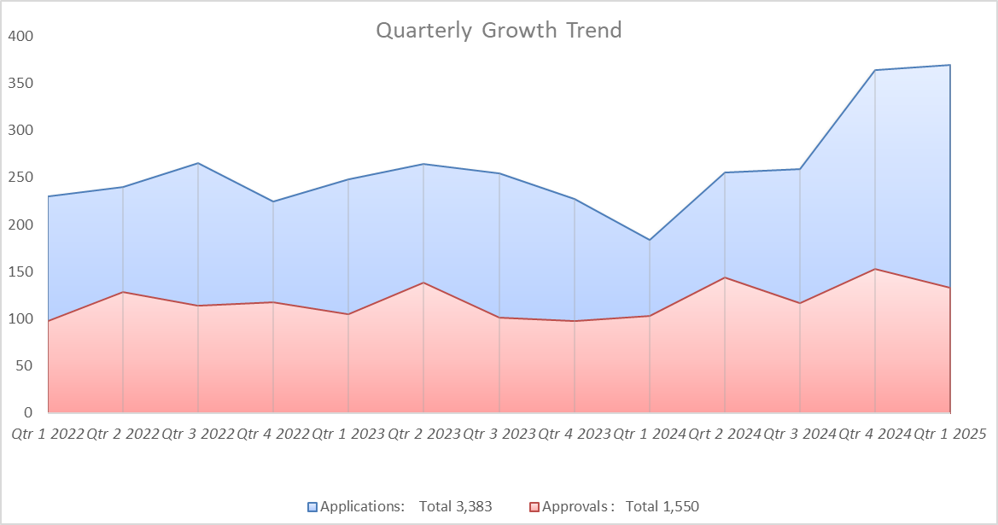

Applications processed (1st January 2025 - 31st March 2025)

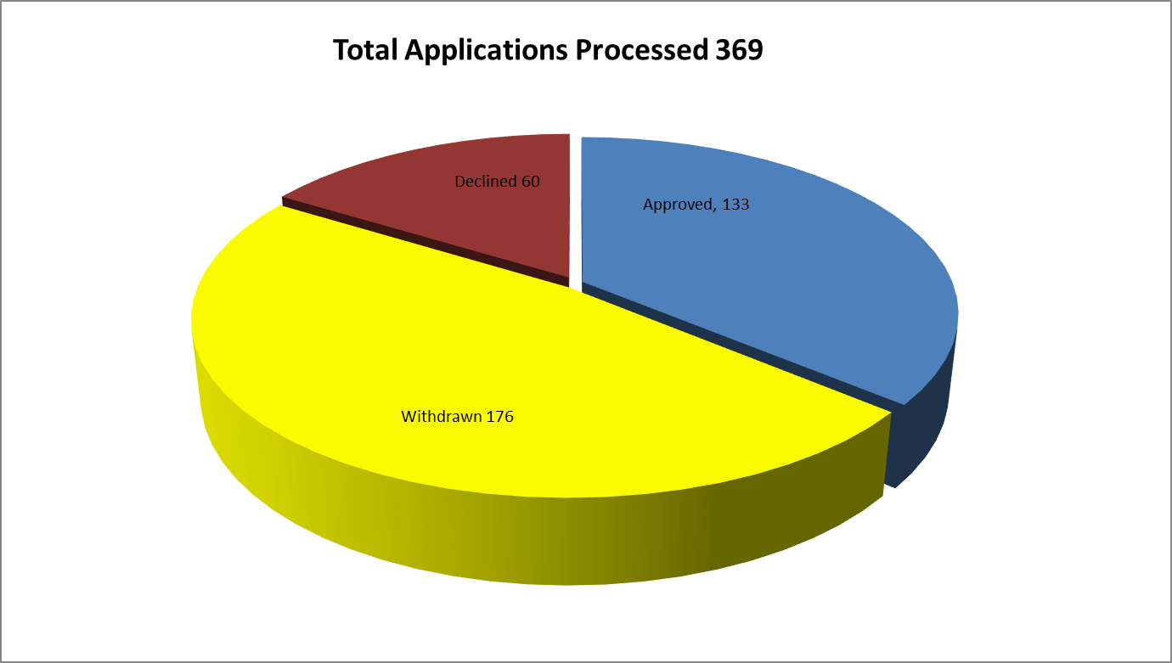

Number of Loans by Sector

Values of Loans by Sector

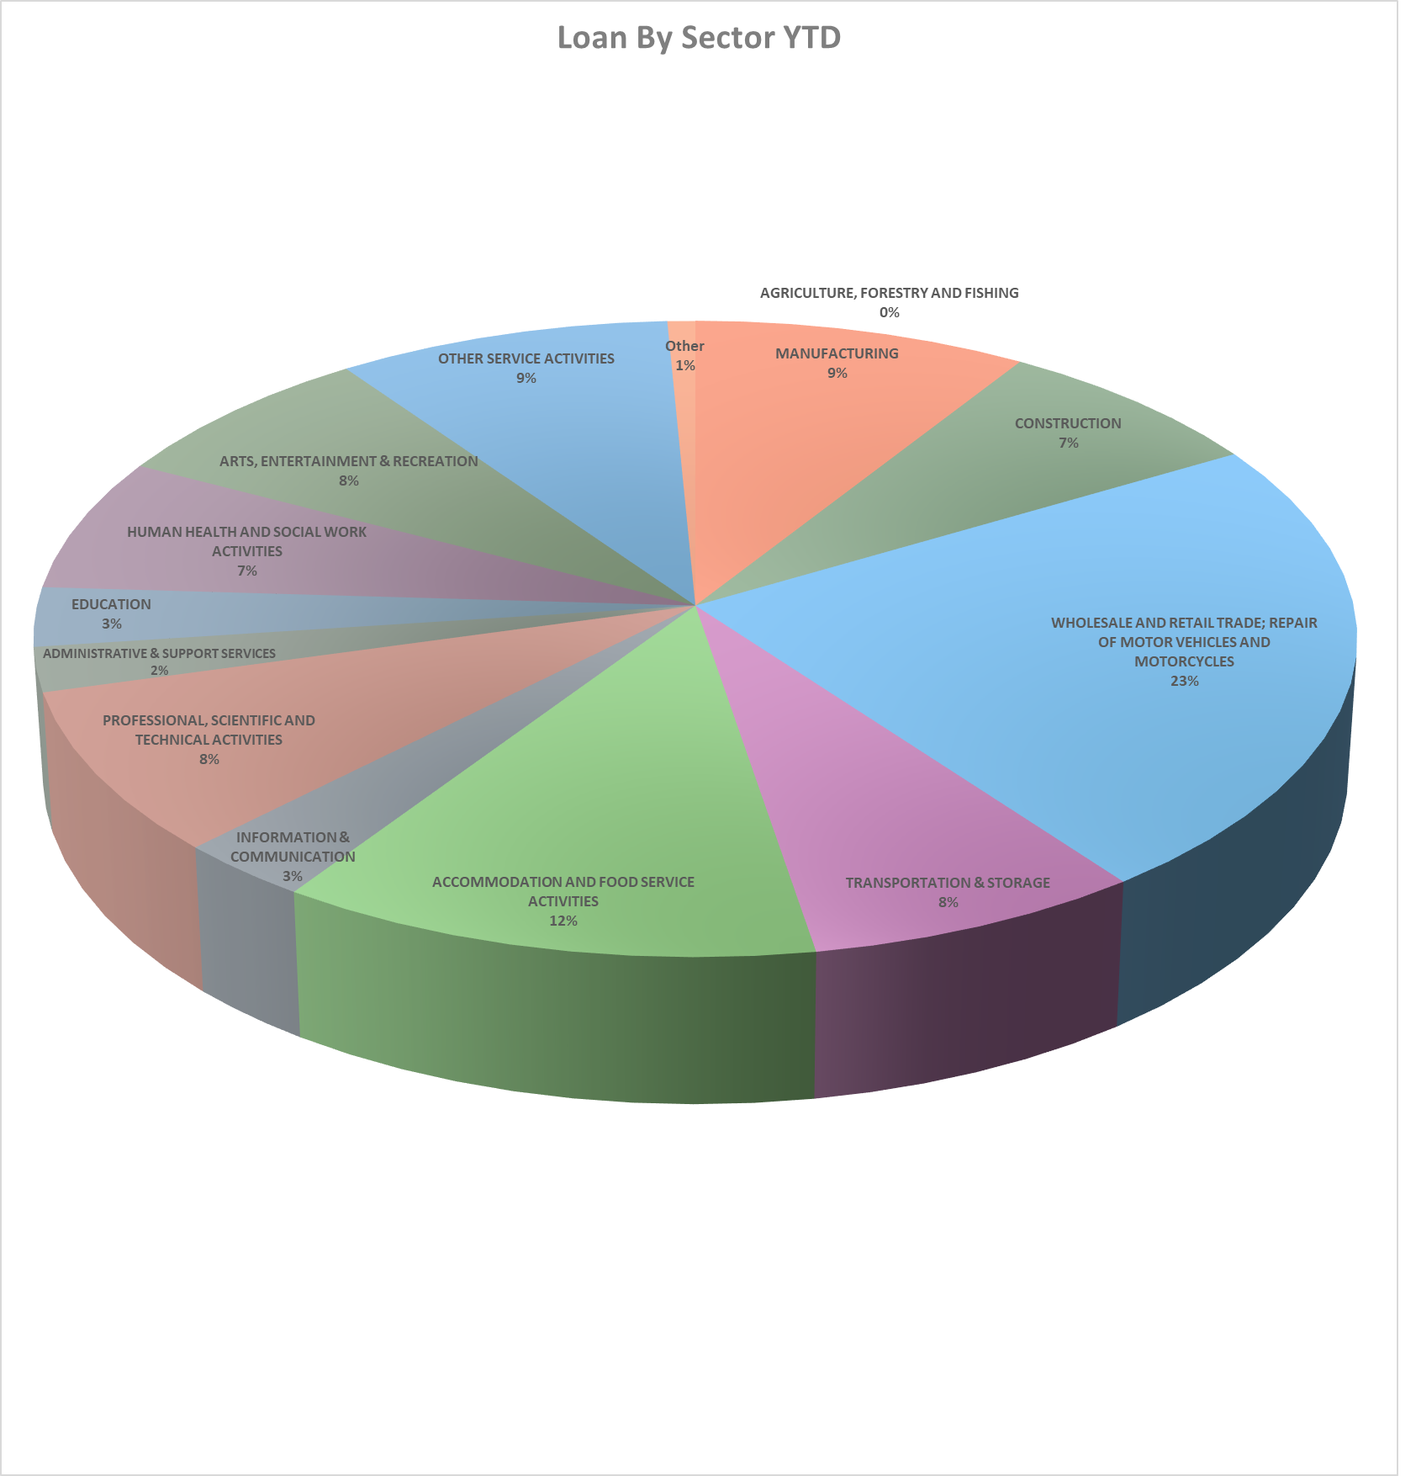

Approvals by Size of Borrower

From 1st January 2022 to 31st March 2025
Loans were approved to micro-enterprises with the following number of jobs at time of approvals:

Approvals by Loan Size
From 1st January 2022 to 31st March 2025, loans were granted in the following size range.

Purpose for which Microfinance Loans were granted.

Geographical Analysis of Approval – from 1st January 2025 to 31st March 2025

Approval by Business Sector January 2025 to 31st March 2025

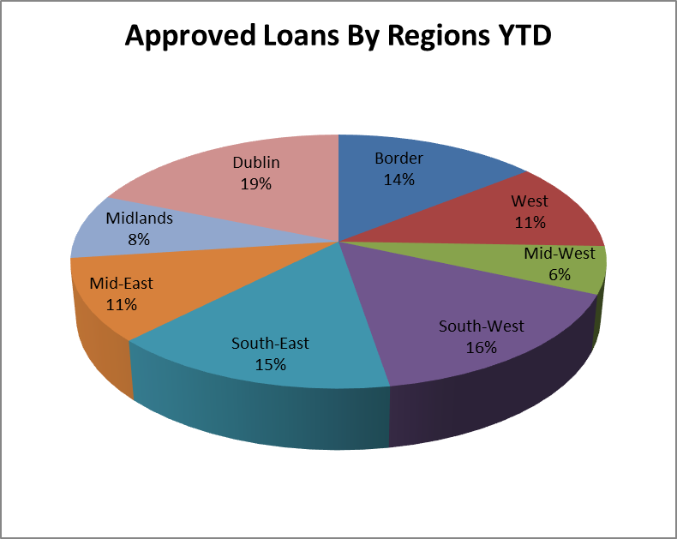

Demographical Analysis

Source of Loan Referrals

Appeals Process
The purpose of the Microfinance Ireland appeals process is to support an applicant who wishes to have a review of an MFI decision to declining a loan application.
MFI will appoint an Appeal Assessor to carry out an independent review of the original loan decision. The assessor who was involved in the original decision will not be involved in the appeals process. The outcome of this review is communicated in writing to the applicant within 15 business days of receipt of the written appeal. The credit decision of the Appeal Assessor is independent of MFI management and is final. There have been 8 appeals in 2025 and 5 of these cases have been approved on appeal. These figures are included in the YTD approval figures.

Complaints
No complaints were received by the business in Quarter 1 2025

Business Failures

During 2025, 34 businesses of our borrowers have failed. While any business failure is regrettable, it was anticipated from the outset that a not insignificant proportion of projects supported by the Microfinance Ireland might fail. It is a feature of microfinance (given the higher risk profile) that even with strong business supports, failures will occur.

On an ongoing basis, Microfinance Ireland, in conjunction with other agencies, works with every customer at risk to minimise business failure.

